System Requirements Specification and Project Plan
Subtitle: CE903 Group Project: Managing Network for LLM Training (Project 3)
Authors: Ashraf Naseer, Bradley Quinlan, Lok Yan Kyle Hui, Navami Nair, Phuthon Thongthawi
Supervisor: Muge Sayit

1. Introduction
This document constitutes the System Requirements Specification (SRS) and Project Plan for the CE903 group project, "Managing Network for LLM Training." It defines the project scope, aims, system requirements, testing strategy, and project management approach for a six-member MSc team working over the 2026 summer term.
The rapid emergence of Large Language Models (LLMs) has necessitated distributed execution across massive GPU clusters.¹ However, conventional datacenter networks are ill-equipped to handle the highly synchronized, micro-burst-heavy traffic patterns generated by LLM training.¹ This structural mismatch leads to severe network bottlenecks, increased training times, and ultimately poor resource utilization.¹ Furthermore, at scales of tens of thousands of GPUs, hardware failures cease to be rare anomalies and instead become continuous operational realities that can catastrophically inflate Job Completion Time (JCT) and waste significant energy.
As an Agile methodology has been adopted ¹², the scope and requirements outlined herein are expected to evolve iteratively prior to the final submission deadline on 3 July 2026. The project is deliberately scoped to reflect the constraints of a six-person team operating over a short term; as agreed with the project supervisor, the objective is not to deploy a production-scale infrastructure, but to deliver a robust, simulation-driven prototype with a rigorous evaluation framework capable of testing novel network-aware scheduling algorithms against these challenges.

1.1 Current Project Status (Initial Sprint Progress)
During Sprint 1, the team selected Project 3, allocated domain responsibilities, and evaluated simulation platform scalability, ultimately rejecting OPNET in favor of ASTRA-sim. An extensive literature review was completed covering LLM traffic patterns (Megatron-LM), GPU fault resilience (UIUC/IBM), and production routing heuristics (MegaScale, CASSINI). The product backlog has been populated with initial user stories, and this SRS document serves as the primary deliverable for the current sprint. Sprint 2 will commence immediately with the extraction of the Hugging Face workload traces.

2. Project Aim and Objectives

2.1 Project Aim
The project aims to design, simulate, and evaluate a predictive, network-aware scheduling and traffic management framework for distributed Large Language Model (LLM) training. The core focus is to quantify how network congestion and GPU hardware failures inflate Job Completion Time (JCT), and to evaluate how intelligent routing can mitigate these disruptions.

2.2 SMART Objectives
- Workload and metrics baseline: By Sprint 2, implement a distributed training workload using Hugging Face (Transformers/Accelerate) and ZeRO-based sharding principles to establish baseline measurements for JCT, step time, throughput, and gradient all-reduce latency.
- Simulation and failure modelling: By Sprint 4, configure a network simulation environment (ASTRA-sim 2.0) that incorporates realistic LLM traffic patterns (Chakra traces) and parametrised GPU failure states based on established Mean Time Between Errors (MTBE).
- Predictive routing implementation: By Sprint 5, integrate a baseline Equal-Cost Multi-Path (ECMP) scheduler alongside a predictive, network-aware routing strategy (leveraging simple ST-GAT or LSTM ensembles) designed to handle periodic all-reduce communication bursts.
- Quantitative evaluation: By Sprint 7, execute simulation scenarios comparing baseline and predictive scheduling under simulated node failures, evaluating success primarily through the reduction of median JCT and recovery time penalties.

3. Acronyms and Definitions
- JCT (Job Completion Time): Total wall-clock time from job submission to successful completion.
- MFU (Model FLOPs Utilization): Useful model FLOPs divided by theoretical available FLOPs, a common metric for LLM training efficiency.¹
- NCCL: NVIDIA Collective Communications Library; optimizes GPU-to-GPU communication (e.g., All-Reduce, All-Gather).¹
- ECMP: Equal-Cost Multi-Path routing; standard datacentre load balancing that is prone to hash collisions under LLM microbursts.¹
- ASTRA-sim: Distributed ML system simulator for modelling network and memory behaviour at the flow level.¹
- OPNET: A discrete-event network simulator (Riverbed Modeler) operating at the packet level.
- RoCEv2: RDMA over Converged Ethernet; a protocol highly sensitive to packet drops, making congestion control critical.¹

4. Domain Literature and Technology Review
To ensure the requirements are technically grounded, a structured domain literature review was conducted covering LLM evolution, parallelism strategies, routing congestion, hardware resilience, and simulation methodologies.

4.1 Evolution of LLMs and Optimization
Language models have evolved rapidly from early Statistical Language Models (SLMs) to massive transformer-based architectures.³ While early iterations like GPT-2 were trained on 1.5 billion parameters, modern models like GPT-4 rely on trillions of parameters trained over clusters of up to 25,000 GPUs.³ The deployment of these massive clusters has pushed researchers to optimize the underlying infrastructure. For example, the Vela system demonstrates a cloud-native architecture using RoCE and GPU Direct RDMA, achieving near-ideal throughput on virtualized environments.⁴⁵ Through extreme optimization—including FP8 matrix multiplication, optimized communication libraries for Mixture of Experts (MoE), and bidirectional pipeline parallelism—models can achieve state-of-the-art performance even on highly constrained hardware.³

4.2 Distributed Parallelism and Collective Communication
Training massive models exceeds the capacity of single GPUs, necessitating complex multi-dimensional parallelism as foundationalized by Megatron-LM (PTD-P).⁶ The Hugging Face Ultra-Scale Playbook details how these strategies generate specific traffic patterns executed by the NVIDIA Collective Communications Library (NCCL).⁷
- Data Parallelism (DP): Generates massive, synchronized "All-Reduce" traffic for gradient synchronization, placing the highest load on the network.⁷
- Tensor Parallelism (TP): Splits individual layers across GPUs, generating frequent All-Reduce/All-Gather traffic within a single node.⁶⁷
- Pipeline Parallelism (PP): Splits model stages across nodes, generating point-to-point Send/Receive traffic.⁶
Recent advancements seek to optimize this communication layer further. For instance, ZipCCL provides hardware-aware lossless data compression directly into the collective communication pipeline to reduce communication volume.⁸⁹ Simultaneously, frameworks like HetCCL enable cross-vendor communication (e.g., NVIDIA and AMD GPUs) while leveraging optimized vendor libraries like NCCL and RCCL.¹⁰¹¹

4.3 Congestion and Network-Aware Scheduling
Because LLM traffic is highly structured and periodic, standard load-balancing algorithms like ECMP fail under the massive, synchronized "elephant flows" generated by All-Reduce bursts, leading to severe hash collisions and congestion.¹²⁹ Research on congestion patterns in large-scale RDMA datacenters reveals that, unlike traditional TCP/IP networks, congestion frequently shifts to the network core under Priority Flow Control (PFC).¹³¹⁴
To proactively manage congestion, advanced frameworks have been developed. CASSINI is a network-aware job scheduler that exploits the predictable nature of DNN training to calculate a microscopic "time-shift" value, delaying job starts so that communication phases from competing jobs interleave rather than collide.⁹ Other state-of-the-art approaches include Reunion, which utilizes Count-Min-Sketch to filter out small flows and aggregate real-time congestion data, allowing source switches to make dynamic rerouting decisions for elephant flows.¹⁵¹⁰ For long-distance clusters, LCMP combines control-plane path-quality scores with on-switch congestion signals to resolve simultaneous flow decision collisions in long-haul RDMA networks.¹⁶¹⁷ Furthermore, systems like FORESIGHT jointly optimize communication scheduling across both time and space to forecast network demands and reduce congestion proactively.¹⁸⁶

4.4 Hardware Resilience and Fault Tolerance
At the scale of modern AI clusters, hardware failures are continuous operational realities. A 12-month study of 428 LLM training failures via the L4 log analysis tool found that 74.1% of failures occur during the iterative training phase.¹⁹ Empirical research by UIUC and IBM revealed that GPU System Processor (GSP) faults occur 30 times more frequently than memory failures, often cascading to completely crash multi-node jobs.²⁰
To combat this without halting training, modern frameworks decouple network failures from the application state. SHIFT is a user-space RDMA layer that provides cross-NIC fault tolerance while preserving correct memory semantics.¹¹²¹ For internal GPU errors, Nonuniform-Tensor-Parallelism (NTP) mitigates GPU failure impact by dynamically adjusting the tensor-parallel degree without completely pausing the system.²²¹⁹ Additionally, OptiReduce introduces resilient and tail-optimal AllReduce for distributed deep learning in the cloud by working with approximated or lost gradients to prevent stragglers from stalling the entire cluster.²³²⁰

4.5 Simulation Tool Selection: The OPNET Consideration
During the project scoping phase, the use of OPNET Modeler (Riverbed Modeler) was strongly considered as the primary simulation environment. OPNET is a highly reputable, commercial Discrete Event Simulator (DES) widely used in academia for modeling precise packet transmission processes and protocol behaviors.
However, upon consultation with the supervisor and a review of recent simulation literature, the OPNET approach was formally rejected. Packet-based simulation approaches cannot scale to the dimensions required for modern AI datacenters (e.g., thousands of interconnected GPUs) without prohibitive computational overhead.
Instead, flow-level simulation offers significant advantages for large-scale datacenter evaluation. The project adopted ASTRA-sim 2.0, which is purpose-built for distributed machine learning.²⁴ Specifically, we utilize the RAPID-LLM methodology, which accurately models Llama inference step latency and GPT-scale training time per batch by assigning per-operator latency using a tile-based model.²⁵¹⁸ ASTRA-sim accepts MLCommons Chakra execution traces and simulates multi-dimensional congestion-aware routing and degraded link faults at a scale that OPNET cannot viably support.²⁴²⁵

5. Requirements Analysis and Specification

5.1 Elicitation and Agile Methodology
Requirements were elicited by translating the aforementioned literature into functional constraints and validating them against CE903 lecture materials on software engineering.²¹ Requirements have been prioritised based on Agile principles, ensuring core baseline capabilities are implemented before stretch objectives.
Because this is an Agile software development project, this initial specification is not exhaustive. Instead, these requirements form the baseline Product Backlog. The complete requirements analysis will be developed iteratively; the backlog will be continuously updated, refined, and reprioritized via user stories during our weekly sprint planning sessions.

5.2 System Architecture and Interaction Models
To meet the CE903 requirement for comprehensive system modelling, the architecture is described via a component dataflow diagram and an interaction (sequence) model for failure handling.

5.2.1 Component Architecture Dataflow
The architecture separates workload generation from network simulation, allowing for modular testing and future extensions.
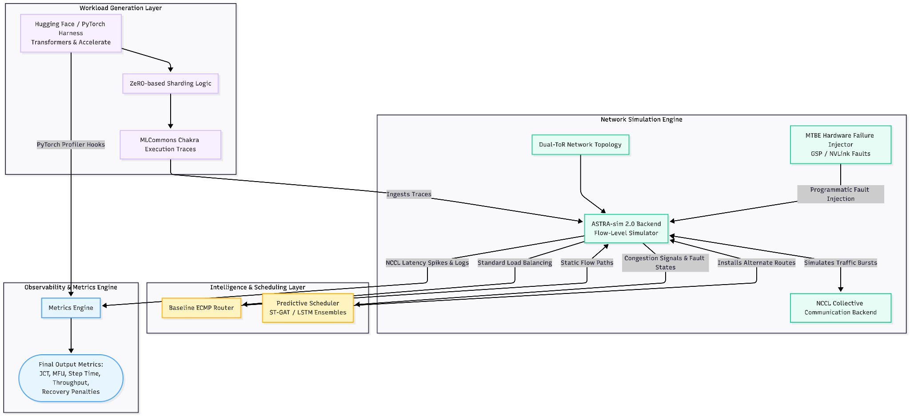Figure 1: Component Architecture Dataflow showing the separation of workload generation (Chakra traces) and the ASTRA-sim 2.0 flow-level simulation environments.

5.2.2 Failure Handling Interaction Model
The failure-handling behaviour can be summarised using the following sequence diagram.
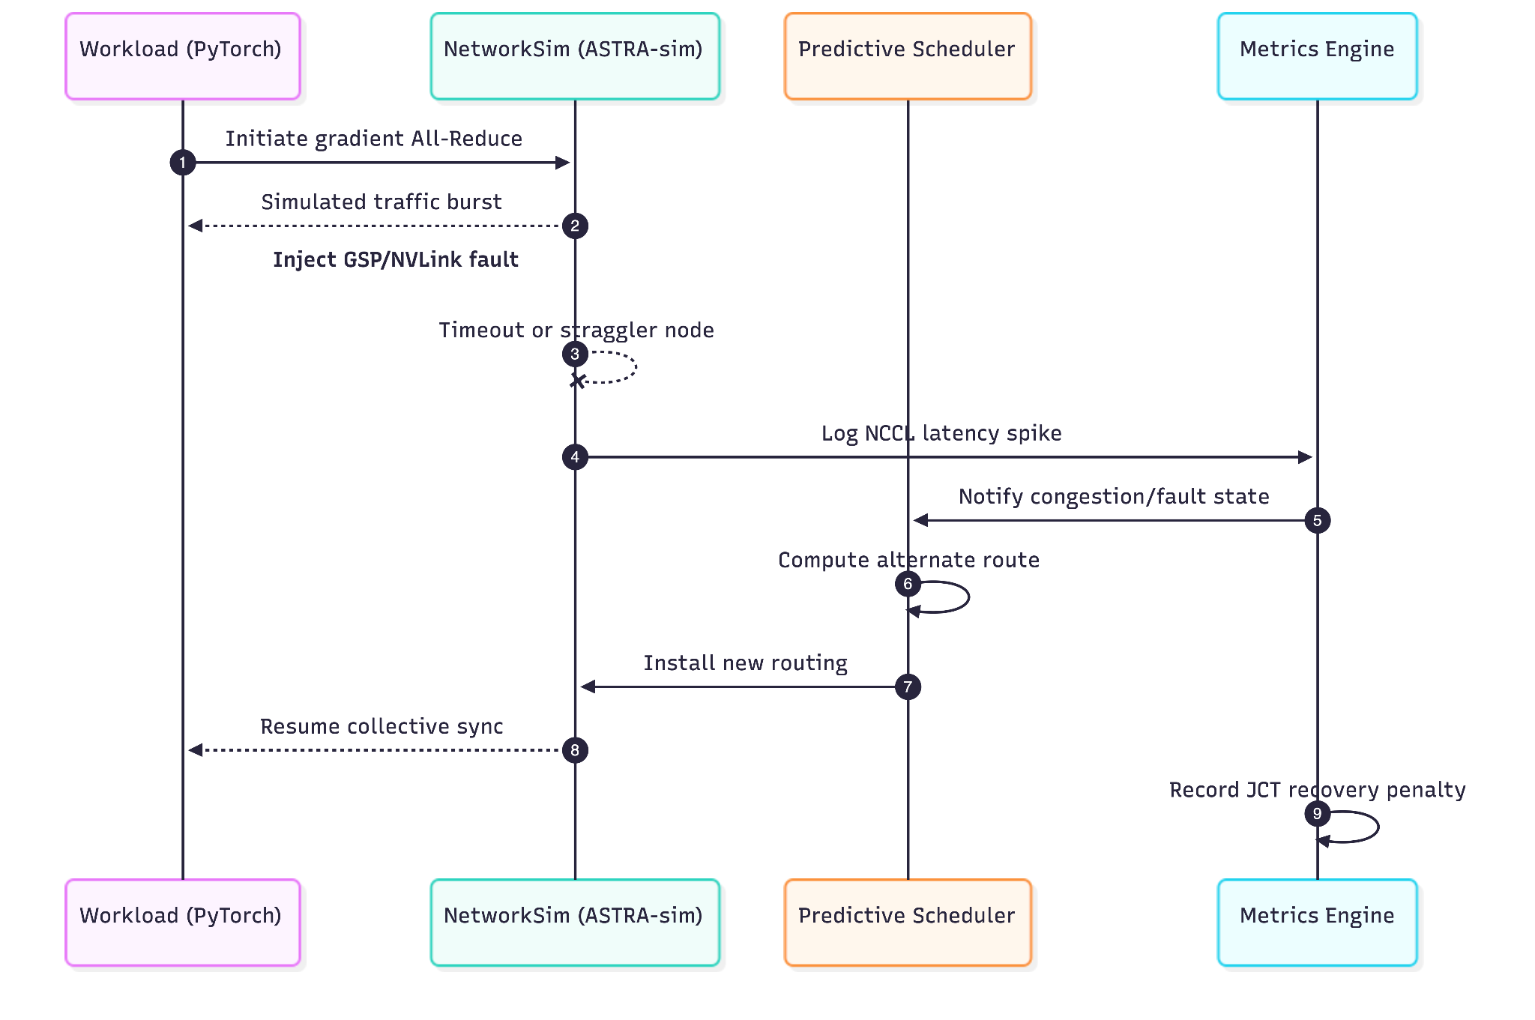Figure 2: Failure Handling Interaction Model outlining the system's temporal response to a simulated hardware fault, inspired by L4 and MegaScale diagnostics.

5.3 Functional Requirements
Following the IEEE 29148 requirements convention, functional requirements denote mandatory system capabilities and are strictly articulated using the modal verb "shall".²³

5.3.1 Workload and Metrics (Area 1)
- FR-M1: The system shall record start time, end time, and completion status to calculate the overarching JCT and Model FLOPs Utilization (MFU) for every simulated training job.¹
- FR-M2: The system shall log per-iteration metrics, specifically step time and token throughput, utilizing PyTorch profiler hooks to isolate compute versus communication time.

5.3.2 Network and GPU Failure Modelling (Area 2)
- FR-G1: The system shall model a network topology capable of replicating massive LLM traffic, inspired by Alibaba’s HPN dual-ToR design, to assess path search complexity and fault redundancy.²⁶
- FR-G2: The system shall allow the programmatic injection of GPU failures based on real-world MTBE statistics (e.g., modeling 99.5% node availability, which equates to ~7 minutes of downtime per GPU per day).²⁰
- FR-G3: The system shall track the propagation chain of hardware faults (e.g., PMU to MMU cascades) to measure the resulting cluster-wide recovery penalty as observed in L4 deployment logs.¹⁹

5.3.3 Prediction Models and Scheduling (Area 3)
- FR-P1: The system shall implement an ECMP baseline router to serve as a control configuration for performance comparisons.
- FR-P2: The system shall implement at least one network-aware scheduling algorithm (e.g., ST-GAT or CASSINI-inspired time-shifting) capable of predicting upcoming all-reduce communication bursts and preemptively avoiding congested routes.⁹

5.3.4 NCCL and Communication (Area 4)
- FR-N1: The system shall establish collective bandwidth and latency baselines by simulating NCCL microbenchmarks (specifically all_reduce_perf and all_gather_perf) within the ASTRA-sim backend.²⁷
- FR-N2: The system shall monitor NCCL timeouts as an indicator of simulated straggler nodes or RoCEv2 packet-drop congestion.

5.4 Non-Functional Requirements
Following the IEEE 29148 requirements convention, non-functional requirements denote recommended goals or constraints and are strictly articulated using the modal verb "should".²³

5.4.1 Product Requirements (Performance and Reliability)
- NFR-P1: The predictive routing policy should demonstrate a measurable reduction in median JCT compared to the static ECMP baseline when a 5% GPU failure rate is introduced mid-training.
- NFR-P2: The system should be capable of processing simulated execution traces (Chakra formats) for a cluster of up to 1024 GPUs within a reasonable timeframe (under 4 hours per run) to allow for iterative Agile testing.

5.4.2 Organisational Requirements
- NFR-O1: The codebase should be modular and version-controlled via Git to allow concurrent development by the six-person team without frequent merge conflicts in the core simulation engine.
- NFR-O2: All experiment configurations should be defined in reproducible YAML or JSON files to ensure testing continuity and reproducibility across team members’ local environments.

6. Verification, Validation and Testing
Testing will be tightly integrated into the Agile sprint cycle. Instead of a monolithic testing phase at the end of the project, acceptance tests are mapped to specific functional requirements iteratively.

6.1 Testing Methods
- Unit testing: Isolated validation of metrics computation (e.g., ensuring JCT and MFU are accurately calculated from raw timestamps without cross-contamination).
- Scenario-based system testing: Using predefined configuration permutations (e.g., Network Load × Failure Rate) as acceptance tests to validate the scheduler’s behaviour under stress.
- Benchmarking: Utilizing nccl-tests logic mapped to ASTRA-sim to validate that the simulated network accurately reflects known communication bottlenecks over PCIe and NVLink topologies.¹

6.2 Testing Schedule
Testing activities are distributed across sprints rather than concentrated at the end of the project, strictly adhering to the CE903 Agile assessment criteria.

Sprint 2 – Baseline metrics and logging
- Focus: Validate that the workload harness and metrics pipeline work end-to-end in a failure-free scenario.
- Activities: Unit tests for JCT calculation; Smoke tests for a single training job on a simple topology.
- Acceptance test (TC‑01): A single LLM training job runs to completion under baseline ECMP routing with 0% failure rate; JCT and throughput are recorded correctly.

Sprint 3 – NCCL and network baselines
- Focus: Establish communication baselines for collective operations over the simulated network.
- Activities: Integrate NCCL microbenchmark logic (all_reduce_perf) into the ASTRA-sim workflow.
- Acceptance test (TC‑02): Simulated all-reduce runs over the baseline topology produce sensible bandwidth and latency curves with no timeouts.

Sprint 4 – Failure injection and observability
- Focus: Introduce and observe GPU and link failures, ensuring they are detected and recorded.
- Activities: Implement MTBE-based failure injection (e.g., GSP crashes) for GPUs and links.
- Acceptance test (TC‑03): When a 5% GPU failure rate is introduced mid-training, the system detects the resulting NCCL stall and logs the "JCT recovery penalty".

Sprint 5 – Predictive versus baseline scheduling
- Focus: Compare ECMP with the predictive network-aware scheduling policy under identical failure patterns.
- Activities: Implement the selected ST‑GAT/LSTM‑based scheduler and execute paired scenarios.
- Acceptance test (TC‑04): Under the same injected failure pattern as TC‑03, the predictive scheduler routes traffic away from congested switches and achieves a lower median JCT than ECMP.

Sprint 6 and beyond – Consolidation and regression
- Focus: Stabilise the prototype and prevent regressions as additional experiments are run.
- Acceptance: All previously passing test cases (TC‑01 to TC‑04) continue to pass on the final codebase without manual hot‑fixes.

7. Project Planning

7.1 Project Management Structure and Methodology
The project utilises a lightweight Agile (Scrumban) framework. The six team members have taken ownership of specific research domains (Metrics, Failures, Prediction, NCCL, and Integration).
- Sprints: One-week iterations, beginning with a stand-up planning session and concluding with a review of simulation outputs.
- Tools: Git/GitHub for version control; Trello/Jira for Kanban backlog management; Shared Word documentation for reports.

7.2 Work Breakdown Structure (WBS)
To ensure clear task decomposition, the project is broken down into the following hierarchy:
- Foundation (May)
1.1 Literature review and domain research (Megatron-LM, MegaScale, etc.)
1.2 SRS document drafting and supervisor approval
1.3 Workload harness generation (Hugging Face / Chakra traces)
- Simulation and Failure (Late May – Early June)
2.1 ASTRA-sim 2.0 environment setup
2.2 Dual-ToR network topology modelling
2.3 MTBE-based GPU failure injection scripting
- Intelligence (Mid-June)
3.1 Baseline ECMP router implementation
3.2 Predictive routing scheduler (ST-GAT/CASSINI-inspired) development
- Evaluation and Submission (Late June – July)
4.1 Batch testing and scenario execution (TC-01 through TC-04)
4.2 Data aggregation and metric analysis (JCT and MFU impact)
4.3 Final report writing and submission

7.3 Gantt Chart Schedule
To mitigate project risks and accommodate the Agile iterative process, explicit slack time (float) has been scheduled at the end of the Intelligence phase and the final Submission phase. This ensures that any overruns during complex predictive scheduler integration do not impact the final July 3rd deadline.
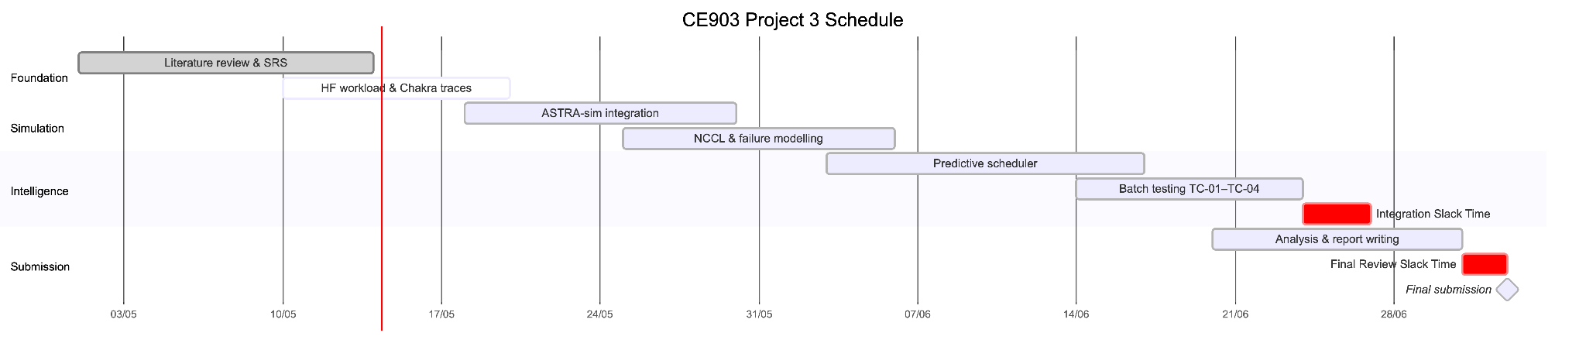Figure 3: Agile Release Plan and Project Schedule, explicitly including designated slack time for risk mitigation.

8. References
¹ C. W. Dawson, Projects in Computing and Information Systems: A Student’s Guide, 2nd ed. Pearson, 2015.
² K. Schwaber and J. Sutherland, The Scrum Guide: The Definitive Guide to Scrum: The Rules of the Game, Scrum.org, 2020.
³ Z. Wang et al., "History, development, and principles of large language models: an introductory survey," AI and Ethics, vol. 5, no. 3, pp. 1955–1971, 2025. ⁶ M. Shoeybi et al., "Megatron-LM: Training Multi-Billion Parameter Language Models Using Model Parallelism," arXiv preprint arXiv:1909.08053, 2019. ⁷ Hugging Face Nanotron Team, "The Ultra-Scale Playbook: Training LLMs on GPU Clusters," 2025. [Online]. Available: https://huggingface.co/spaces/nanotron/ultrascale-playbook ¹² Z. Jiang et al., "MegaScale: Scaling Large Language Model Training to More Than 10,000 GPUs," 21st USENIX Symposium on Networked Systems Design and Implementation (NSDI 24), 2024. ⁹ S. Timilsina and S. Shannigrahi, "CASSINI: Network-Aware Job Scheduling in Machine Learning Clusters," NSDI, 2024. ²⁴ Y. Zhang et al., "ASTRA-sim2.0: Modeling Hierarchical Networks and Disaggregated Systems for ML Training," Proc. ASPLOS, 2023.
²⁵ G. Karfakis et al., "RAPID-LLM: Resilience-Aware Performance analysis of Infrastructure for Distributed LLM Training and Inference," arXiv preprint arXiv:2512.19606, 2025. ¹¹ S. Lin et al., "SHIFT: An RDMA Failure-Resilient Layer for Distributed Training," arXiv preprint arXiv:2512.11094, 2025. ¹⁵ M. Wang et al., "Reunion: Receiver-driven network load balancing mechanism in AI training clusters," Computer Networks, vol. 259, p. 111088, 2025. ¹⁶ D.-Y. Yu et al., "LCMP: Distributed Long-Haul Cost-Aware Multi-Path Routing for Inter-Datacenter RDMA Networks," Proceedings of the ACM 21th Eurosys Conference, 2026. ²⁰ UIUC and IBM Research, "Characterizing GPU Resilience and Impact on AI/HPC Systems," IEEE/ACM Int. Symposium on Cluster, Cloud and Internet Computing, 2025.
²⁶ C. Qian et al., "Alibaba HPN: A Data Center Network for Large Language Model Training," ACM SIGCOMM, 2024.
¹⁹ Z. B. Chern et al., "L4: Diagnosing Large-scale LLM Training Failures via Automated Log Analysis," Proc. ESEC/FSE, 2025.
²⁷ NVIDIA, "NVIDIA Collective Communications Library (NCCL) Developer Guide," 2025. [Online]. Available: https://docs.nvidia.com/deeplearning/nccl/
²¹ I. Sommerville, Software Engineering, 9th ed. Addison-Wesley, 2010. ²³ ISO/IEC/IEEE, "ISO/IEC/IEEE International Standard - Systems and software engineering -- Life cycle processes -- Requirements engineering," ISO/IEC/IEEE 29148:2018, 2018. ¹⁰ E. Warraich et al., "OptiReduce: Resilient and Tail-Optimal AllReduce for Distributed Deep Learning in the Cloud," 22nd USENIX Symposium on Networked Systems Design and Implementation (NSDI 25), 2025. ⁸ H. Kim et al., "HetCCL: Accelerating LLM Training with Heterogeneous GPUs," arXiv preprint arXiv:2601.22585, 2026. ⁴ W. Lin et al., "ZipCCL: Efficient Lossless Data Compression of Communication Collectives for Accelerating LLM Training," arXiv preprint arXiv:2604.27844, 2026. ²² A. Mohan et al., "Vela: A Virtualized LLM Training System with GPU Direct RoCE," ASPLOS, 2025. ¹³ D. Arfeen et al., "Nonuniform-Tensor-Parallelism: Mitigating GPU failure impact for Scaled-up LLM Training," arXiv preprint arXiv:2504.06095, 2025. ²⁸ S. Ghorbani et al., "Congestion Patterns in a Large-scale RDMA Datacenter," ACM Internet Measurement Conference (IMC), 2025. ¹⁸ F. Yang et al., "Holmes: Towards Distributed Training Across Clusters with Heterogeneous NIC Environment," arXiv preprint arXiv:2312.03549, 2023. ²⁹ S. Timilsina and S. Shannigrahi, "FORESIGHT: Learning to Schedule: A Supervised Learning Framework for Network-Aware Scheduling of Data-Intensive Workloads," arXiv preprint arXiv:2510.21419, 2025.

Works cited

- Training LLMs with Fault Tolerant HSDP on 100,000 GPUs - arXiv, accessed on May 13, 2026, https://arxiv.org/pdf/2602.00277
- A Novel Framework for Dissecting AI Data Center Network Efficiency - arXiv, accessed on May 13, 2026, https://arxiv.org/pdf/2604.14690
- Congestion Analysis in RDMA Datacenters | PDF - Scribd, accessed on May 13, 2026, https://www.scribd.com/document/958706759/imc2025-cycle2-paper161
- Vela: A Virtualized LLM Training System with GPU Direct RoCE - Semantic Scholar, accessed on May 13, 2026, https://www.semanticscholar.org/paper/Vela%3A-A-Virtualized-LLM-Training-System-with-GPU-Mohan-Walkup/6ef42fd2756167f5e0e47f33fd284f99692a078f
- FORESIGHT: Joint Time and Space Scheduling for Efficient Distributed ML Training - IFIP Networking Conference, accessed on May 13, 2026, https://networking.ifip.org/2025/images/Net25_papers/1571125810.pdf
- A Switch-Centric In-Network Architecture for Accelerating LLM Inference in Shared-Memory Network - arXiv, accessed on May 13, 2026, https://arxiv.org/html/2603.28239v2
- LCMP: Distributed Long-Haul Cost-Aware Multi-Path Routing for Inter-Datacenter RDMA Networks - arXiv, accessed on May 13, 2026, https://arxiv.org/html/2604.07836v1
- ZipCCL: Efficient Lossless Data Compression of Communication Collectives for Accelerating LLM Training - arXiv, accessed on May 13, 2026, https://arxiv.org/html/2604.27844v1
- Reunion: Receiver-driven network load balancing mechanism in AI training clusters - Peirui Cao, accessed on May 13, 2026, https://caopeirui.github.io/paper/Reunion_CN25.pdf
- (PDF) HetCCL: Accelerating LLM Training with Heterogeneous GPUs - ResearchGate, accessed on May 13, 2026, https://www.researchgate.net/publication/400340010_HetCCL_Accelerating_LLM_Training_with_Heterogeneous_GPUs
- ZipCCL: Efficient Lossless Data Compression of Communication Collectives for Accelerating LLM Training - ResearchGate, accessed on May 13, 2026, https://www.researchgate.net/publication/404333308_ZipCCL_Efficient_Lossless_Data_Compression_of_Communication_Collectives_for_Accelerating_LLM_Training
- Holmes: Towards Distributed Training Across Clusters with Heterogeneous NIC Environment - arXiv, accessed on May 13, 2026, https://arxiv.org/html/2312.03549v1
- (PDF) Congestion Patterns in a Large-scale RDMA Datacenter - ResearchGate, accessed on May 13, 2026, https://www.researchgate.net/publication/396561710_Congestion_Patterns_in_a_Large-scale_RDMA_Datacenter
- OptiReduce: Resilient and Tail-Optimal AllReduce for Distributed Deep Learning in the Cloud - USENIX, accessed on May 13, 2026, https://www.usenix.org/system/files/nsdi25-warraich.pdf
- 22nd NSDI 2025 - DBLP, accessed on May 13, 2026, https://dblp.org/db/conf/nsdi/nsdi2025
- LCMP: Distributed Long-Haul Cost-Aware Multi-Path Routing for Inter-Datacenter RDMA Networks | Request PDF - ResearchGate, accessed on May 13, 2026, https://www.researchgate.net/publication/400270998_LCMP_Distributed_Long-Haul_Cost-Aware_Multi-Path_Routing_for_Inter-Datacenter_RDMA_Networks
- [2512.19606] RAPID-LLM: Resilience-Aware Performance analysis of Infrastructure for Distributed LLM Training and Inference - arXiv, accessed on May 13, 2026, https://arxiv.org/abs/2512.19606
- Nonuniform-Tensor-Parallelism: Mitigating GPU failure impact for Scaled-up LLM Training, accessed on May 13, 2026, https://arxiv.org/html/2504.06095v1
- arXiv:2310.06993v2 [cs.DC] 3 May 2025, accessed on May 13, 2026, https://arxiv.org/pdf/2310.06993
- SHIFT: An RDMA Failure-Resilient Layer for Distributed Training - arXiv, accessed on May 13, 2026, https://arxiv.org/html/2512.11094v1
- Holmes: Towards Distributed Training Across Clusters with Heterogeneous NIC Environment - arXiv, accessed on May 13, 2026, https://arxiv.org/html/2312.03549v4
- SHIFT: Exploring the Boundary of RDMA Network Fault Tolerance - arXiv, accessed on May 13, 2026, https://arxiv.org/html/2512.11094v2
- 1 Introduction - arXiv, accessed on May 13, 2026, https://arxiv.org/html/2604.17172v1
- HetCCL: Accelerating LLM Training with Heterogeneous GPUs - arXiv, accessed on May 13, 2026, https://arxiv.org/html/2601.22585v1
- Characterizing GPU Resilience and Impact on AI/HPC Systems - arXiv, accessed on May 13, 2026, https://arxiv.org/html/2503.11901v2
- Doctoral Thesis Proposal - Daiyaan Arfeen | Carnegie Mellon University Computer Science Department, accessed on May 13, 2026, https://csd.cs.cmu.edu/calendar/2025-06-17/doctoral-thesis-proposal-daiyaan-arfeen
- RAPID-LLM: Resilience-Aware Performance analysis of Infrastructure for Distributed LLM Training and Inference - arXiv, accessed on May 13, 2026, https://arxiv.org/html/2512.19606v1
- RAPID-LLM: Resilience-Aware Performance analysis of Infrastructure for Distributed LLM Training and Inference - arXiv, accessed on May 13, 2026, https://arxiv.org/pdf/2512.19606

